|  |  |  |  |
| --- | --- | --- | --- |
| **Team number** | 4 | **Section** | 3 |
| **Team Members** | 1. Victor Martinez 2. Benjamin Reyes 3. Diego Sanchez | | |
| **Software Name** | Mixionary (Cocktail Recipe Book) | | |

## Introduction

* 1. Objective [5 Points]  
     [Explain what this document is about, who are the audiences, what background is needed to understand it.]

This document is a Technical Specification for our Cocktail Recipe Book, Mixionary. The audiences are other programmers who hope to use the code in order to implement it in their own code. As well as other programmers, the target audience is anyone over the age of 21 that is trying to make a cocktail drink. Not much background is needed to understand the computer application. If you want to understand the code behind the application then a familiarity with basic sorting algorithms is helpful as well as a simple understanding of OOD.

* 1. References [5 Points]  
     [Mention the references of all documents, websites, books, etc., you used for creating this document.]

Mixel is an app that’s only available on a phone. It’s a great app that helps us use it as a reference to where we want to take this computer software that we’re creating.

Mixel: <https://www.mixelcocktails.com/>

VioletUML Editor is the software that we used to be able to create our UML diagrams

VioletUml: <http://alexdp.free.fr/violetumleditor/page.php>

* 1. Acronyms, and abbreviations [5 Points]  
     [Explain all acronyms and abbreviations used in this document.]

|  |  |
| --- | --- |
| OOD | Object-Oriented Design |
|  |  |
|  |  |

## Software overview

* 1. Problem statement [5 Points]  
     [Explain what problem this software is going to solve.]

It’s going to solve the problem for someone who is looking for a cocktail recipe app. A place for users to be able to find other recipes or for them to make their own and upload them. Users will be able to make their own accounts and log-in to it. Users can be able to interact with one another’s recipe by rating them or favoriting them. Users can add whatever recipe they want to their recipe book. The app will have different ways to search: title, ingredient, calories.

* 1. Scope [5 Points]  
     [Explain the boundaries of the product   
     (e.g.: what kind of users this product would target).]

This product would target individuals over the age of 21. If a person is 21 then we would target anyone who is looking for a recipe book for cocktails. The product could also be useful for other programmers who want to implement the code for their own coding projects.

## Detailed Design

* 1. UML Class diagrams (for all classes) [20 Points]

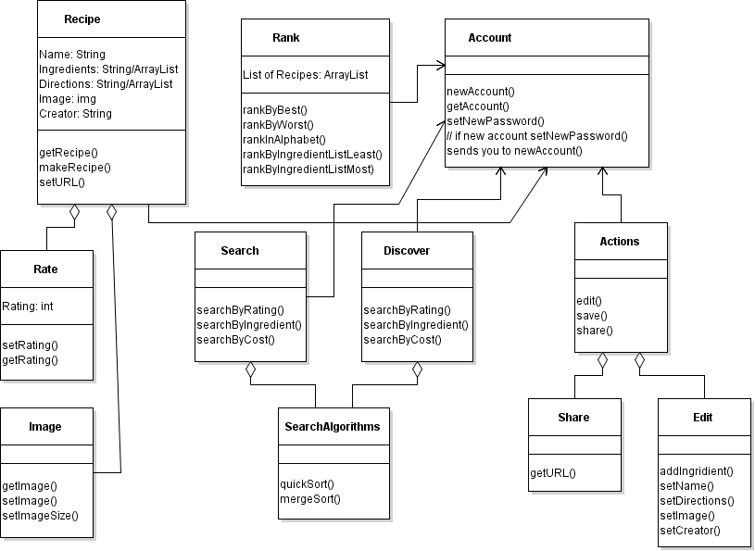

* 1. UML Sequence and/or state diagrams (at least one) [10 Points]

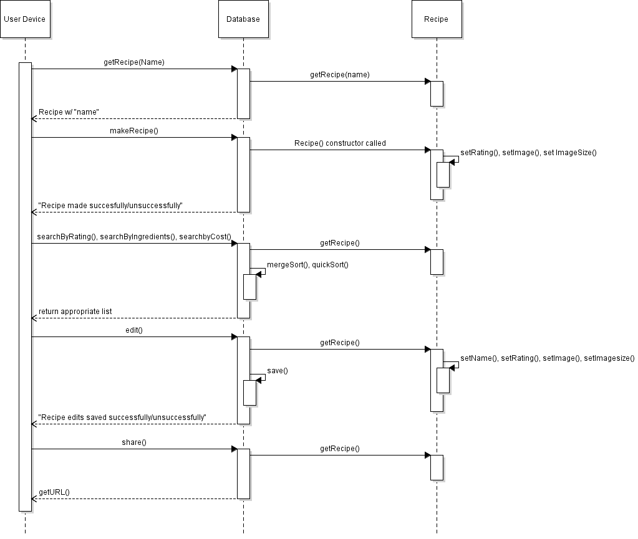

* 1. User Interface [15 Points]  
     [Include user interfaces snapshots (real or mockups) (at least 3)]

**Main Menu**

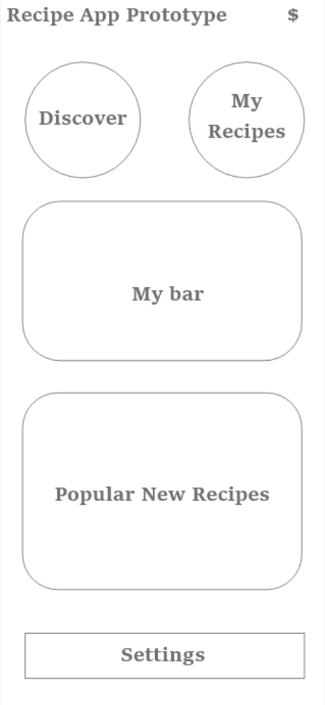

**Recipe Inventory**

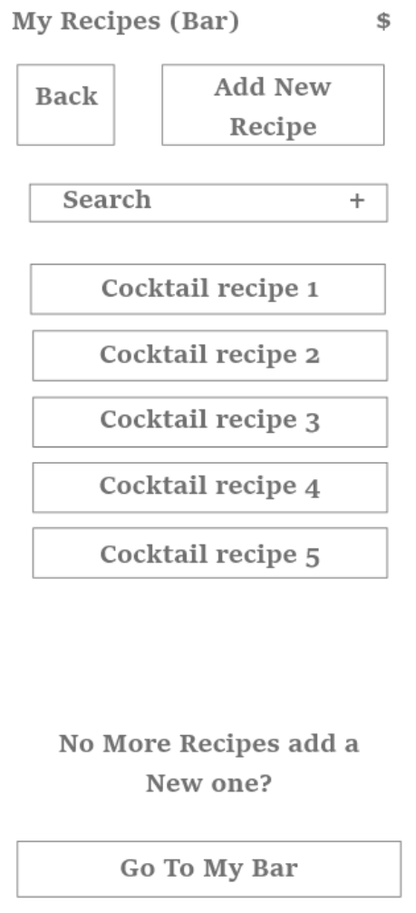

**Recipe**

